Suprematism 1915 - 1920s

Suprematism is the painting of light, from colour to light itself. Originally developed by Kazimir Malevich in 1915 (he showed 39 Suprematist canvases in the Last Futurist Exhibition of Paintings 0.10, Petrograd, December 1915-January 1916), the word ‘Suprematism’ meant, according to him, “dominant”, a common artist’s term which here referred specifically to colour in the painter’s eye and so on the canvas. Suprematism could be said to be the logical development of Parisian Impressionism, the exploration of colour in light and that of Claude Monet in particular. Originating in optical afterimages in 1915, Malevich went on to use spinning discs and light projectors, 1916-1919, to capture light itself. Artists in Malevich’s milieu such as Ivan Kliun began to investigate colour using discs in 1914, while between 1916 and 1919 there was a surge of experimentation with discs and projectors. Kliun, Alexandra Exter, Liubov Popova, Aleksandr Rodchenko and Olga Rozanova produced a great variety of paintings of colour and light and, apart from Exter, they showed together at the first major group exhibition, Non-Objective Creation and Suprematism (Moscow, 1919). In 1920 Malevich went to teach at the Practical Art Institute in Vitebsk where El Lissitzky adapted architectural geometrical systems to a Suprematism of the cosmos, and Malevich’s students such as Ilia Chashnik and Nikolai Suetin also moved on to the Suprematism of cosmic space and infinity, seen at the 1923 Petrograd Exhibition of All Trends, the final manifestation of Suprematist painting. These artists adapted Suprematism to the design of porcelain and graphics in the 1920s.

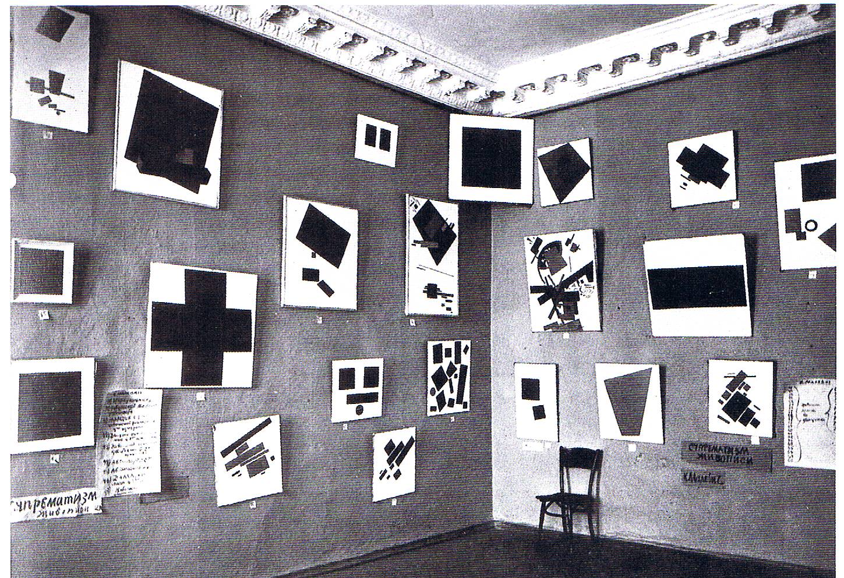
Last Futurist Exhibition of Paintings 0.10, Petrograd, December 1915-January 1916

Exploring how the eye sees colour and light, Kazimir Malevich began experimenting with the optical phenomenon of afterimages produced in the eye by strong light, notably the sun, when fields of bright, luminous colours at the light-end of the spectrum appear – reds, oranges, yellows. If the light is diminished by, say, a cloud passing over, colours at the dark-end of the spectrum appear – greens, blues, violets. Malevich then organised these phenomena of optical, spectral colours in a luminous field of light, the white canvas, using a geometrical system, most commonly that of how the eye actually sees; he sometimes used a simplified non-Euclidean geometry in order to capture wide, expansive spatiality. In 1916, Malevich began to explore a particular characteristic of vision, that of luminosity. For this he used spinning discs, a device employed by scientists for measuring luminosity in the eye, Malevich’s source being Hermann von Helmholtz’s scientific Treatise on Physiological Optics of the 1860s. He titled these works ‘Supremus’. In the spinning discs Malevich became aware of the energy of centrifugal forces and he did a group of “Supr[ematist] Construction of Colour” in 1917-1918 which he called “Non-Objective Suprematism”, “non-objective” referring to these forces. In 1917, following the initiative of Rozanova, Malevich began to compose with beams of coloured light thrown onto a screen by light projectors. This was followed in 1918 and 1919 by his White on White canvases, paintings of light itself. In 1919 and 1920, canvases titled ‘Suprematism of the Spirit’ was a Suprematism of the space of infinity which only the mind can imagine.

References and further reading:
Matthew Drutt (ed.), Suprematism, Berlin: Guggenheim Museum, 2003.
Patricia Railing, Malevich Paints – The Seeing Eye, Forest Row: Artists Bookworks, 2013.
State Russian Museum, Malevich’s Circle – Confederates, Students, Followers in Russia
1920s- 1950s, St. Petersburg: Palace Editions, 2000.
Larissa A. Zhadova, Malevich – Suprematism and Revolution in Russian Art 1910-1930,
London: Thames and Hudson, 1978.

